 | 
Project Report
on
“Write your Project Title”
A Dissertation submitted in partial fulfillment of the requirements for the award of degree of
MASTER OF COMPUTER APPLICATIONS
Of
Visvesvaraya Technological University (VTU)

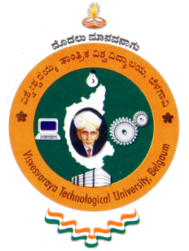
Submitted By
Name in capital letters
USN: Mention your USN
Under the guidance of

Internal Guide  Guide Name  Designation  Department of MCA  NMIT, Bengaluru |  | External Guide  Guide Name  Designation  Company Address
MAY 2026

